Analyzing Deauthentication Packets with Wireshark

Regardless of whether you are reading a packet capture from a stored file or from a live interface on a Windows or Linux host, Wireshark’s analysis features are nearly identical. Wireshark offers many useful features for analyzing wireless traffic, including detailed protocol dissectors, powerful display filters, customizable display properties, and the ability to decrypt wireless traffic.
Let’s start with analyzing the Deauthentication Packets/Frames with Wireshark.
Deauthentication request can be send either with aireplay-ng or with mdk3 tool. But make sure that your card must listen on same channel as the AP is operating on.
For Deauthentication with Aireplay-ng, the command is:

Command: aireplay-ng -00 -a <BSSID> wlan0mon
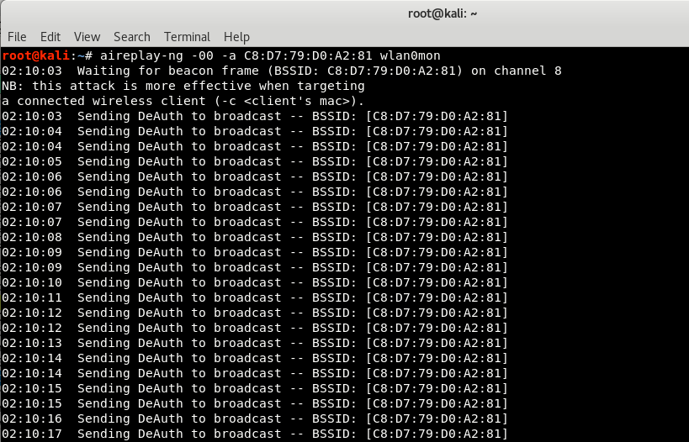
Where,
- -0 specifies the number of times the attack has to replay and -00 means no limit which will flood the AP and station with deauth frames.
- -a is the target’s BSSID
- wlan0mon is your monitor interface
Sending a few deauth frames are enough to successfully disconnect the stations in case of performing tests and capturing handshakes. A long attack will keep the device from connecting and the end would be the device user will have to connect manually from Wi-Fi Manager.

About Wireshark –
Wireshark is the best open-source network analyzer available. It is packed with features comparable to commercial network analyzers, and with a large, diverse collection of authors, new enhancements are continually developed.
Wireshark is a stable and useful component for all network toolkits, and new features and bug fixes are always being developed. A lot of progress has been made since the early days of Wireshark (when it was still called Ethereal); the application now performs comparably (and in some regards) better than commercial sniffing software.
One of the most powerful and useful features in Wireshark is the ability to apply inclusive or exclusive display filters to a packet capture, in order to narrow down the number of packets to those containing useful data. When capturing traffic on a wireless network, it is easy to become overwhelmed by the sheer quantity of data that is captured.

Starting Wireshark –
Start Wireshark by running the wireshark executable with no command line arguments as the root user, and initiate a new packet capture by pressing Capture | Options. This opens the “Wireshark Capture” options dialog box. Choose the wireless interface which is wlan0mon (in our case) that has been placed in monitor mode by selecting the drop-down box labelled “Interface:” and then specify the desired capture options.
In order to begin sniffing wireless traffic with Wireshark, your wireless card must be in monitor mode. Wireshark does not do this automatically; you have to manually configure your wireless card before starting your packet capture.
Next, click Start to initiate the packet capture. At this point, you’ve configured your system to capture wireless traffic in monitor mode.The next step is to utilize the information contained in the packets you are capturing. Fortunately,Wireshark has sophisticated analysis mechanisms that can be used for wireless traffic analysis.
Using display filters, you can exclude uninteresting traffic to reveal useful information, or search through a large packet capture for a specific set of information.
For Filtering Deauthentication Frames, the filter is:
(wlan.fc.type == 0) && (wlan.fc.type_subtype == 0x0c)
OR
(wlan.fc.type eq 0) && (wlan.fc.type_subtype eq 0x0c)
OR
(wlan.fc.type eq 0) && (wlan.fc.type_subtype eq 12)

Here, type field of deauth frame have value 0 while subtype has the value 0x0c (12).
The Type field is included in the frame wlan.fc.type control header and specifies the type of frame (data, management, or control) whereas The Type/Subtype field value is included as a convenience mechanism to uniquely identify the type and subtype combination that is included in the header of this frame. This field is commonly used in display filters.
For example, if the frame is a type management frame, the subtype field indicates the type of management frame (e.g., a beacon frame, authenticate request, or disassociate notice).
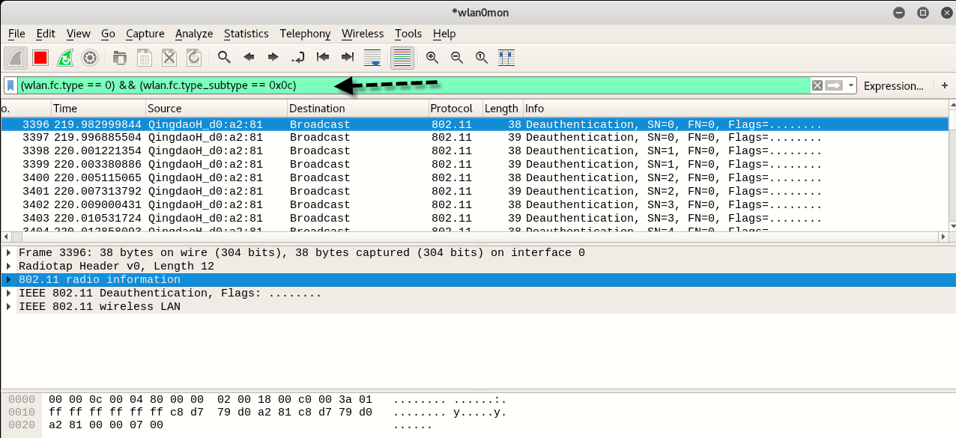

When assessing a wireless packet capture with Wireshark, it is common to apply display filters to look for or exclude certain frames based on the IEEE 802.11 frame type and frame subtype fields.
If you are trying to exclude frames from a capture, it is easy to identify the Type and Subtype fields by navigating the Packet Details window and using the values for your filter. If you are looking for a specific frame type, however, you have to remember either the Frame Type and Subtype values, or the Combined Type/Subtype value assigned by Wireshark.

Instead of expecting you to memorize the 35+ values for different frame types, we’ve listed out here for easy reference.

Frame Type/Subtype | Filter
Management Frames | wlan.fc.type eq 0
Control Frames | wlan.fc.type eq 1
Data Frames | wlan.fc.type eq 2
Association Request | wlan.fc.type_subtype eq 0
Association response | wlan.fc.type_subtype eq 1
Reassociation Request | wlan.fc.type_subtype eq 2
Reassociation Response | wlan.fc.type_subtype eq 3
Probe Request | wlan.fc.type_subtype eq 4
Probe Response | wlan.fc.type_subtype eq 5
Beacon | wlan.fc.type_subtype eq 8
Announcement Traffic Indication MAP (ATIM) | wlan.fc.type_subtype eq 9
Disassociate | wlan.fc.type_subtype eq 10
Authentication | wlan.fc.type_subtype eq 11
Deauthentication | wlan.fc.type_subtype eq 12
Action Frames | wlan.fc.type_subtype eq 13
Block Acknowledgement (ACK) Request | wlan.fc.type_subtype eq 24
Block ACK | wlan.fc.type_subtype eq 25
Power-Save Poll | wlan.fc.type_subtype eq 26
Request to Send | wlan.fc.type_subtype eq 27
Clear to Send | wlan.fc.type_subtype eq 28
ACK | wlan.fc.type_subtype eq 29
Contention Free Period End | wlan.fc.type_subtype eq 30
Contention Free Period End ACK | wlan.fc.type_subtype eq 31
Data + Contention Free ACK | wlan.fc.type_subtype eq 33
Data + Contention Free Poll | wlan.fc.type_subtype eq 34
Data + Contention Free ACK + Contention Free Poll | wlan.fc.type_subtype eq 35
NULL Data | wlan.fc.type_subtype eq 36
NULL Data + Contention Free ACK | wlan.fc.type_subtype eq 37
NULL Data + Contention Free Poll | wlan.fc.type_subtype eq 38
NULL Data + Contention Free ACK + Contention Free Poll | wlan.fc.type_subtype eq 39
QoS Data | wlan.fc.type_subtype eq 40
QoS Data + Contention Free ACK | wlan.fc.type_subtype eq 41
QoS Data + Contention Free Poll | wlan.fc.type_subtype eq 42
QoS Data + Contention Free ACK + Contention Free Poll | wlan.fc.type_subtype eq 43
NULL QoS Data | wlan.fc.type_subtype eq 44
NULL QoS Data + Contention Free Poll | wlan.fc.type_subtype eq 46
NULL QoS Data + Contention Free ACK + Contention Free Poll | wlan.fc.type_subtype eq 47

